Activity 1
DC Motors

Student Name: ZHI CHEN Student No: 20144855

Part 1.
Complete lesson 21 from the Elegoo Super Starter kit.

Part 2

Hardware Required
- Arduino Uno R3 Board
- 2 X DC Motors (Kit)
- L293D motor driver board
- 12V Plugpack
- hook-up wires
- breadboard

Overview

How to control speed and direction of 2 DC motors using the L298N motor driver board with Arduino Uno R3

We will use the 12V Plugpack to provide required power as the Arduino cannot supply enough voltage/current.

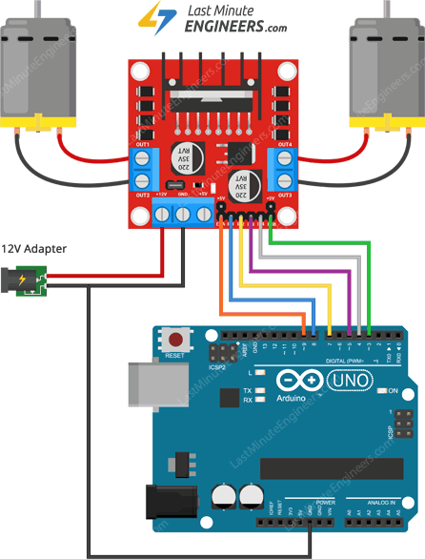
Wiring

+5V – RED
GND – Black

ENA – Arduino pin 9
ENB – Arduino pin 3

L298N Board
Motor 1 – Output 1 & 2
Motor 2 – Output 3 & 5
IN1 - Arduino pin 8
IN2- Arduino pin 7
IN3 – Arduino pin 5
IN4 - Arduino pin 4

**Leave regulator enable jumper in place as motors supply is less than 12V**

Program code is available on Blackboard under Assessments/Activity 1

- Insert picture of your working DC Motor Lab Part 2 here, must include your name!
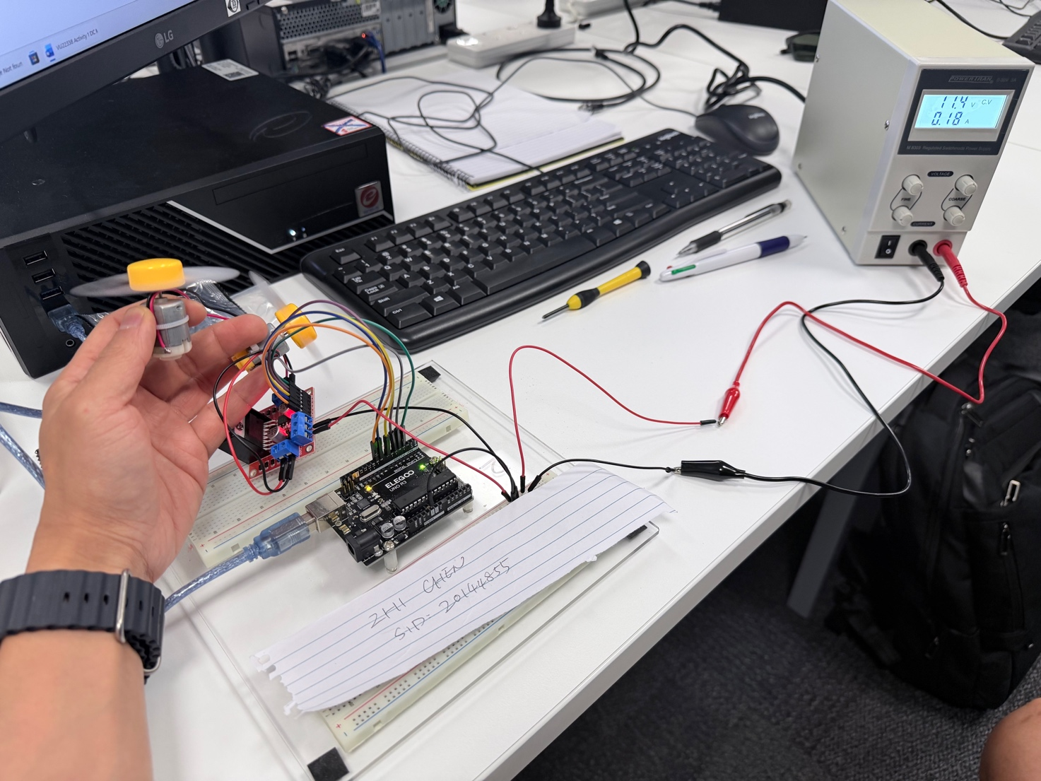

- The most common actuator in mobile robotics (in general) is the ……. Motor

- AC
- DC
- Three phase
- Solenoid

- The circuit below is called a ……………… and will give direction control of a ………… motor.
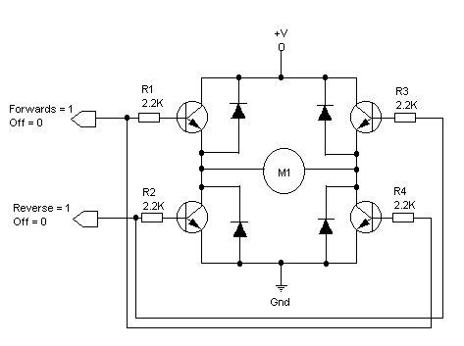
- T bridge, DC

- T bridge, AC

- H bridge, DC

- H bridge, AC

- Write a for loop count from 0 to 50.
for (int i = 0; i <= 50; i++) {
Serial.print("Current Count: ");
Serial.println(i);
delay(100);
}

- Flemings left hand rule uses conventional current flow.

- Name 6 parts of a DC motor.
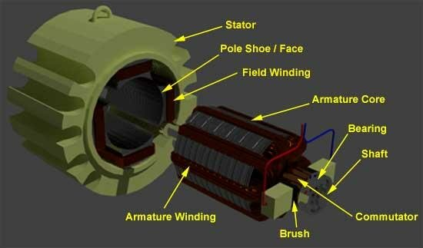

    - Stator
    - Field winding
    - Armature
    - Brushes
    - Commutator
    - Shaft

- Why is a permanent magnet so called?

Because it retains its magnetic properties without needing an external power source.

- In a typical 3 coil DC motor how far apart are the coils in degrees?

120 degree, as a full circle is 360 degree, 3 coils are spaced at 360/3 =120 degrees.

END

Please submit completed worksheet in blackboard

